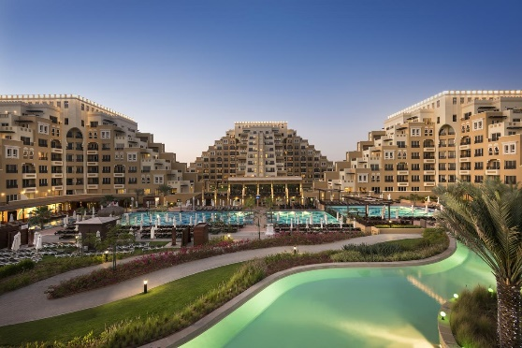
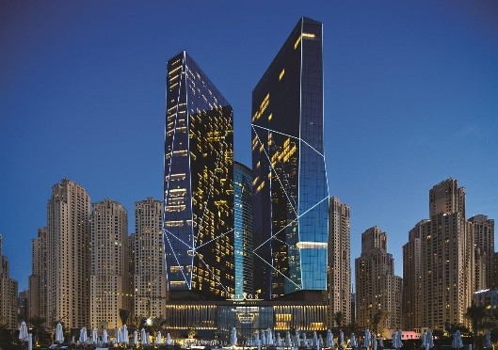
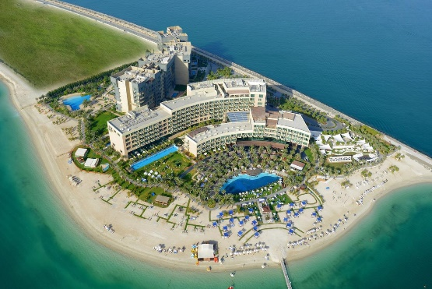
Программа VIP RIXOS FAM TRIP
В Объединенные Арабские Эмираты
23.06.2018 – 30.06.2018

HOTEL : DUKES HOTEL
CHECK IN : 23 JUNE 2018 CHECK OUT: 25 JUNE 2018
HOTEL : RIXOS THE PALM
CHECK IN : 25 JUNE 2018 CHECK OUT: 26 JUNE 2018
HOTEL : RIXOS PREMIUM
CHECK IN : 26 JUNE 2018 CHECK OUT: 28 JUNE 2018
HOTEL : RIXOS BAB AL BAHR
CHECK IN : 28 JUNE 2018 CHECK OUT: 30 JUNE 2018

JUNE 24 2018
09:45 – 10:45 – DUKES THE PALM
11.00 – 11:45 – WYNDHAM DUBAI MARINA
12: 00 – 12:45 – MARINA VIEW
12:45 – 14:30 – MOVENPICK JBR WITH LUNCH
15:00 – 15:45 – ARMADA BLUEBAY
15: 45 – 16:30 – PULLMAN JLT

JUNE 25 2018
10:00 – 10:45 – MEDIA ROTANA
11: 00 – 11:45 – FIRST CENTRAL
12:00 – 14:00 – TRYP BY WYNDHAM WITH LUNCH
14:15 – 15:00 GOLDEN TULIP AL BARSHA
15:15 – 16:00 – HILTON GARDEN MALL OF THE EMIRATES

JUNE 26 2018
09:30 – 10:30 – RIXOS THE PALM
11: 15 – 12:00 – RADISSON WATERFORNT
12:15 – 14:00 – RAMADA DOWNTOWN WITH LUNCH
14:15 – 15: 45 – WESTIN, ST. REGIS, W HOTEL AL HABTOOR
16:00 – 17:00 – CROWNE PLAZE DUBAI

JUNE 27 2018
09:30 – 10:30 – RIXOS PREMIUM HOTEL
11:00 – 10:45 – FRASER SUITES
11: 15 – 12:00 – IBIS STYLE JUMEIRAH
12: 20 – 13:00 – GRAND EXCELSIOR BUR DUBAI
13:20 – 15:00 – RAMADA JUMEIRAH WITH LUNCH

JUNE 28 2018
DEPARTURE TO RIXOS BAB AL BAHR AND FREE TIME

Обращаем внимание, что туристический дирхам в рекламных турах ОАЭ оплачивается агентом самостоятельно.
Программа тура может быть изменена и дополнена

